Madron YFC was established in 1949 and is continuously growing in size. We meet on a Friday night at 7.30 pm. The majority of meetings are held in Landithy Hall. Although, during the summer we like to get out and about. We take part in a large range of competitions from public speaking to baking and Drama.
If you would like to know more, don’t hesitate to message us on our Facebook page Madron Young Farmers club or e-mail us on madronyfc@outlook.com
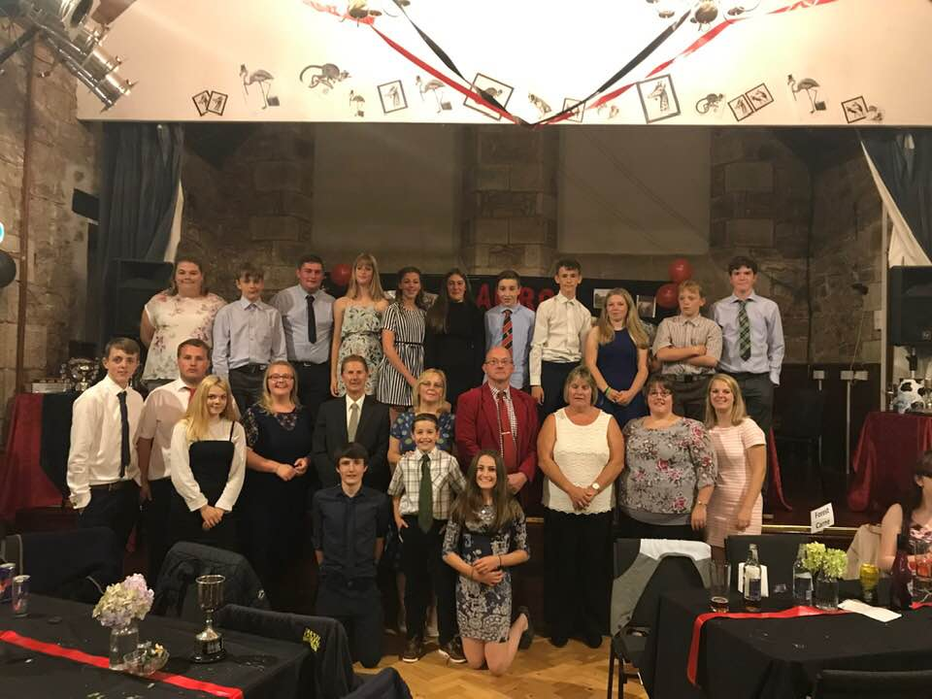
--------------------------------------------------------------------------------------------------------------------------------------

On Sunday 2nd February, thirteen members of Madron young farmers headed up to Liskeard town hall for the Cornwall young farmers drama competition. Having our rehearsal slot at 9.30am it was an early start for the members but fuelled by McDonalds breakfast we made the journey up.
We were lucky that the production company doing the lighting had a court scene set that we could use. This saved the club a lot of time and money as we would not have been able to produce a set of that quality on our own. Because of this, part of out 45 minute rehearsal period was learning how to get the set ready for the performance, leaving us with enough time to run through the drama once. There were a few notes taken during the rehearsal that we tried to put in place for the competition later that day.
When it came to the performance, to say we were nervous was a bit of an understatement. We had put a lot of work into this and we just didn’t want to make fools of ourselves. We had a slight technical issue, with one of the mics not working as we were about to start. Luckily, this member has taken part in performances outside of young farmers and was happy to go without. The performance went well, with only a couple of small mistakes that were covered up well.
When it came to the results, we were all on tender hooks. Charlotte Vincent won best actress and we then went and won best producer. At this we were all sat on the edge of our seats wondering if we had done it. When they announced that we had won, we were all ecstatic. This win really wasn’t expected as our only aim was to not make fools of ourselves and for everyone to enjoy themselves.
We are now through to the South West Area rounds at the Regal Theatre in Redruth on Sunday 8th March. At this event we will be competing against one club from each county in the south west.

